**SAVITRIBAI PHULE PUNE UNIVERSITY**

**A PRELIMINARY MINI PROJECT ON**

**Client-Server Architecture Based Job Posting Site.**

SUBMITTED TOWARDS THE

PARTIAL FULFILLMENT OF THE REQUIREMENTS OF

**Bachelor of Engineering (Computer Engineering)**

**BY**

Yash Garudkar 55

Anushree Sisodia 14

Mohit Sonawane 74

**Under the Guidance of**

Prof. Pramod Patil



DEPARTMENT OF COMPUTER ENGINEERING

**Sandip Foundation,**

**Sandip Institute of Technology & Research Centre, Nashik (2019-20)**



**Sandip Foundation,**

**Sandip Institute of Technology & Research Centre, Nashik (2019-20)**

DEPARTMENT OF COMPUTER ENGINEERING

**CERTIFICATE**

This is to certify that the Mini Project Entitled

**Client-Server Architecture Based Job Posting Site.**

Submitted by

Yash Garudkar 55

Anushree Sisodia 14

Mohit Sonawane 74

Is a bonafide work carried out by Students under the supervision of Prof. Pramod Patil and it is submitted towards the partial fulfillment of the requirement of Fourth Year of Engineering (Computer Engineering) Mini Project.

Prof. Pramod Patil Prof. AMOL POTGANTWAR

Internal Guide H.O.D

Dept. of Computer Engineering. Dept. of Computer Engineering.

**Acknowledgments**

*It gives us great pleasure in presenting the mini project on “****Job Posting Site”***

*I would like to take this opportunity to thank my internal guide Prof. Pramod Patil Sir for giving me all the help and guidance I needed. I am really grateful to them for their kind support. Their valuable suggestions were very helpful.*

*I am also grateful to Prof. Amol Potgantwar, Head of Computer Engineering Department, Sandip Institute of Technology & Research Centre, Nashik for his indispensable support, suggestions, for Our Project.*

Yash Garudkar

Mohit Sonawane

Anushree Sisodia

(B.E. Computer Engg.)

**Contents**

Abstract

Introduction

Preface

Drawback of existing system

Need for New System

Software Requirement

Diagrams

Implementation Highlights

System Architecture

Input / Output

Conclusion

Future Scope

**Abstract**

The aim of this project is to develops an online search Portal for the Placement Dept. of the college. This system can also be used as an Online Job Portal for the Placement Dept of the college to manage the student information with regards to placement. Students logging should be able to upload their information in the form of a CV. Visitors/Company representatives logging in may also access/search any information put up by Students. The project has been planned to be having the view of distributed architecture, with centralized storage of the database. The application for the storage of the data has been planned. Using the XAMPP Server for PHP and all the user interfaces have been designed using the HTML and CSS. The database connectivity is planned using the “SQL Connection” methodology. The standards of security and data protective mechanism have been given a big choice for proper usage. The application takes care of different modules and their associated reports, which are produced as per the applicable strategies and standards that are put forwarded by the administrative staff.

**Introduction**

This project is aimed at developing an online search Portal for the Placement Details for job seekers. The system is an online application that can be accessed throughout the organization and outside as well with proper login provided. This system can be used as an Online Job Portal for job seekers. Job Seekers logging should be able to upload their information in the form of a CV. Visitors/Company representatives logging in may also access/search any information put up by Job aspirants.

**Purpose of Project**

This system can be used as an Online Job Portal for the Placements providing to the job seekers for a job placement. Job Seeker logging into the system and he can should be able to upload their information in the form of a CV. Visitors/Company representatives logging in may also access/search any information put up by Job Seeker**.**

**Analysis Model:**

The model that is basically being followed is the WATER FALL MODEL, which states that the phases are organized in a linear order. First of all the feasibility study is done. Once that part is over the requirement analysis and project planning begins. If system exists one and modification and addition of new module is needed, analysis of present system can be used as basic model.

The design starts after the requirement analysis is complete and the coding begins after the design is complete. Once the programming is completed, the testing is done.

Here the linear ordering of these activities is critical. End of the phase and the output of one phase is the input of other phase. The output of each phase is to be consistent with the overall requirement of the system. Some of the qualities of spiral model are also incorporated like after the people concerned with the project review completion of each of the phase the work done.

WATER FALL MODEL was being chosen because all requirements were known beforehand and the objective of our software development is the computerization/automation of an already existing manual working system.

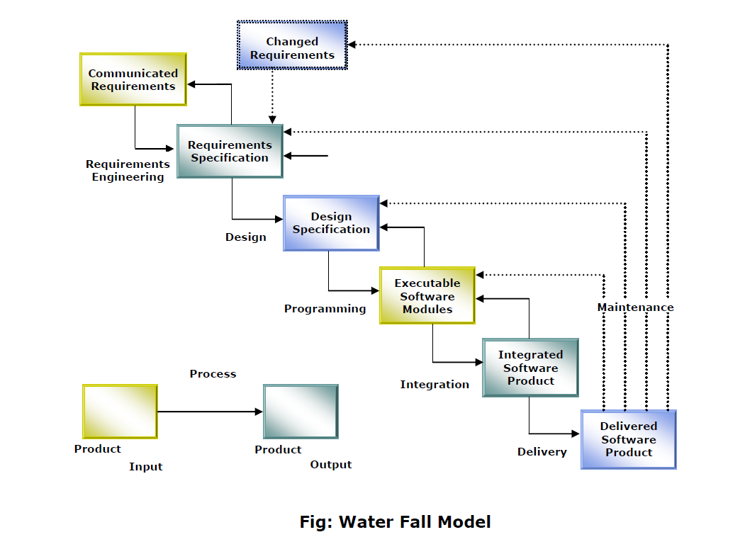

**Drawbacks of Existing system**

* Existing system are a failing in providing quick operation
* Cost is high as well.
* Processing very lengthy and time consuming.
* More time consume for before generation.

**Need for new System**

1. Proposed Job Portal system consists of 3 modules: Job Seeker, Employer and Administrator.

2. Online Job Portal will provide the fast operation and low cost expense than old system.

3. Easy job search, which is a job seeker need

**Software Requirements**

Operating System : Window XP, Windows 7  
Front –End : HTML, Java Script, PHP  
Back-End : PHP, MYSQL  
Supporting Server : Apache Tomcat 5.5 , WampServer

**Diagrams:**

**DFG 1 (Job seeker)**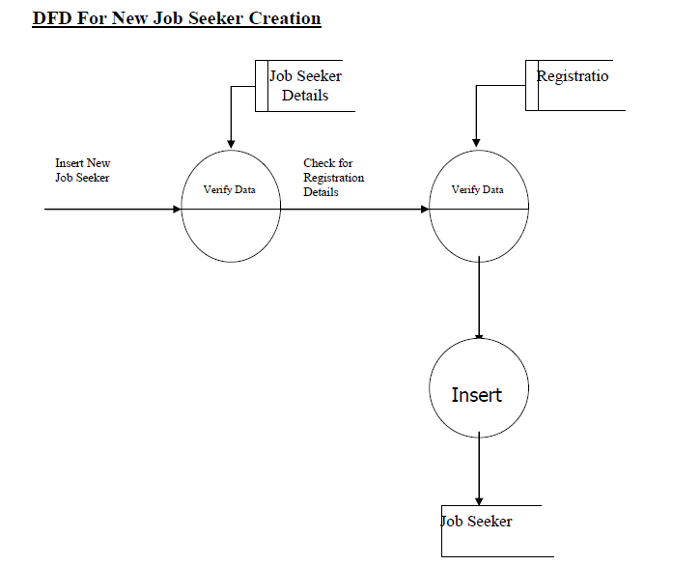

**DFG 2 (Job Search)**

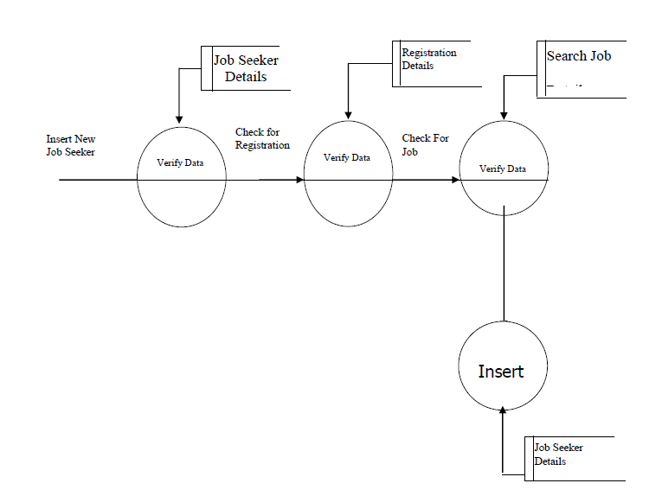

**Data Flow Diagram:**

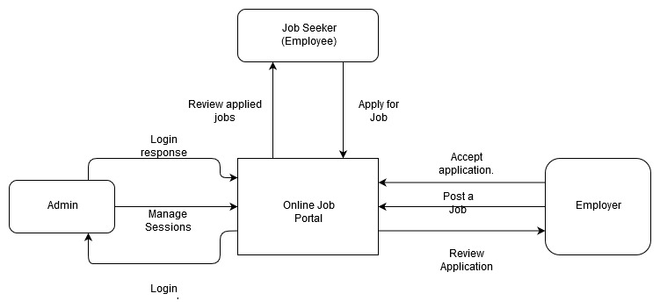

**System Architecture:**

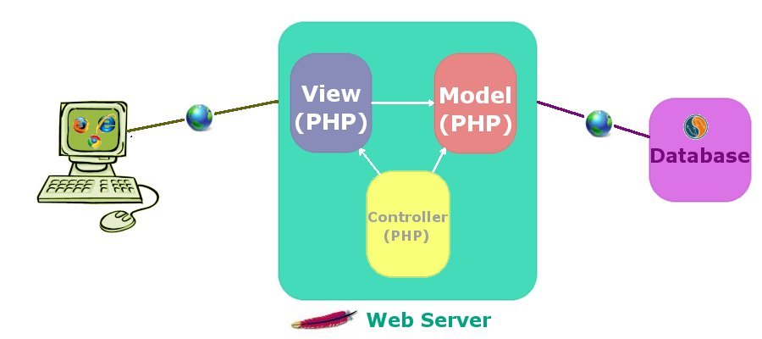

**Implementation Highlights (PHP)**

The PHP software works with the *web server,* which is the software that delivers web pages to the world*.* When you type a URL into your web browser’s address bar, you’re sending a message to the web server at that URL, asking it to send you an HTML file. The web server responds by sending the requested file. Your browser reads the HTML file and displays the web page.

You also request a file from the web server when you click a link in a web page. In addition, the web server processes a file when you click a web page button that submits a form. This process is essentially the same when PHP is installed. You request a file, the web server happens to be running PHP, and it sends HTML back to the browser, thanks to the programming in PHP.

More specifically, when PHP is installed, the web server is configured to expect certain file extensions to contain PHP language statements. Often the extension is .php or .phtml, but any extension can be used. When the web server gets a request for a file with the designated extension, it sends the HTML statements as is, but PHP statements are processed by the PHP software before they’re sent to the requester.

When PHP language statements are processed, only the output, or anything printed to the screen is sent by the web server to the web browser. The PHP language statements, those that don’t produce any output to the screen, aren’t included in the output sent to the browser, so the PHP code is not normally seen by the user.

For instance, in this simple PHP statement, <?php is the PHP opening tag, and ?> is the closing tag.

<?php echo "<p>Hello World</p>"; ?>

Here, echo is a PHP instruction that tells PHP to output the upcoming text. The PHP software processes the PHP statement and outputs the following:

<p>Hello World</p>

That regular HTML statement is delivered to the user’s browser. The browser interprets the statement as HTML code and displays a web page with one paragraph — Hello World. The PHP statement isn’t delivered to the browser, so the user never sees any PHP statements. PHP and the web server must work closely together.

**Use of XAMPP for PHP Server:**

**What is XAMPP?**

XAMPP is a free and open-source cross-platform web server solution stack package developed by Apache Friends, it consists of the Apache HTTP Server, MariaDB database and interpreters for PHP scripts and Perl programming languages. Since most actual web server deployments use the same components as XAMPP, it makes transitioning from a local test server to a live server possible.

XAMPP for Windows is essentially an assortment of free software tools that help install and use Apache HTTP Server. In other words, it's an Apache distribution comprising Apache Web Server, PHP, MySQL, phpMyAdmin, Perl, FileZilla FTP Server, etc. The primary philosophy is to create an easy distribution setup for developers who are entering the Apache world.

XAMPP is a complete tool for dynamic and web developers. The bundle is open source and free and has been designed primarily for professionals. That said, amateurs can also come on-board and master XAMPP for Windows if they are willing to invest the time and effort needed to learn the tool.

**XAMPP Module:** 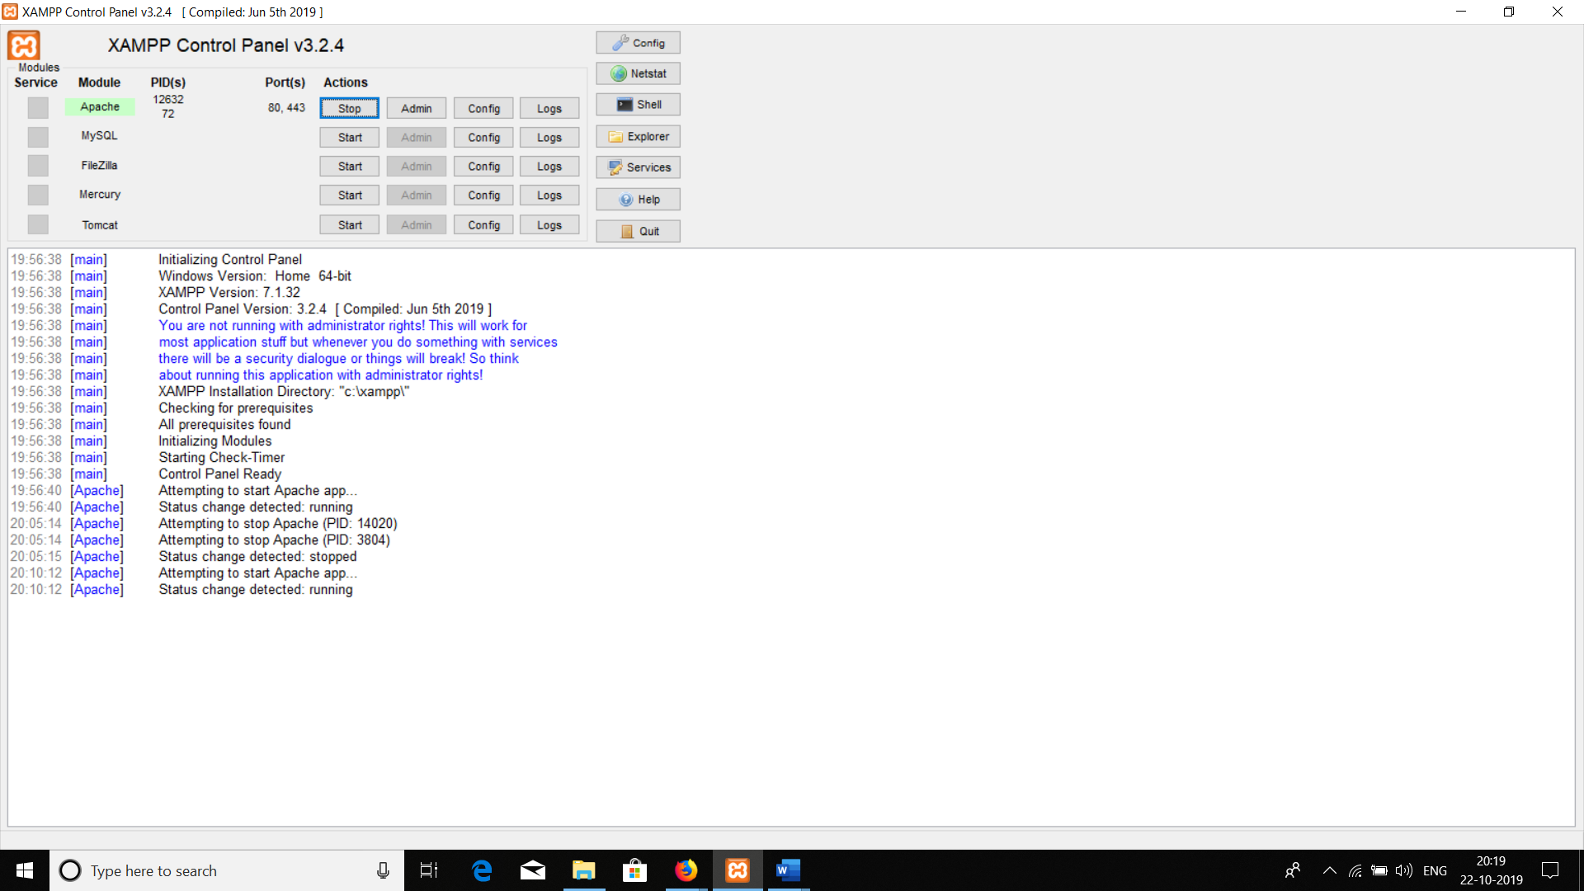

**Input / Output**

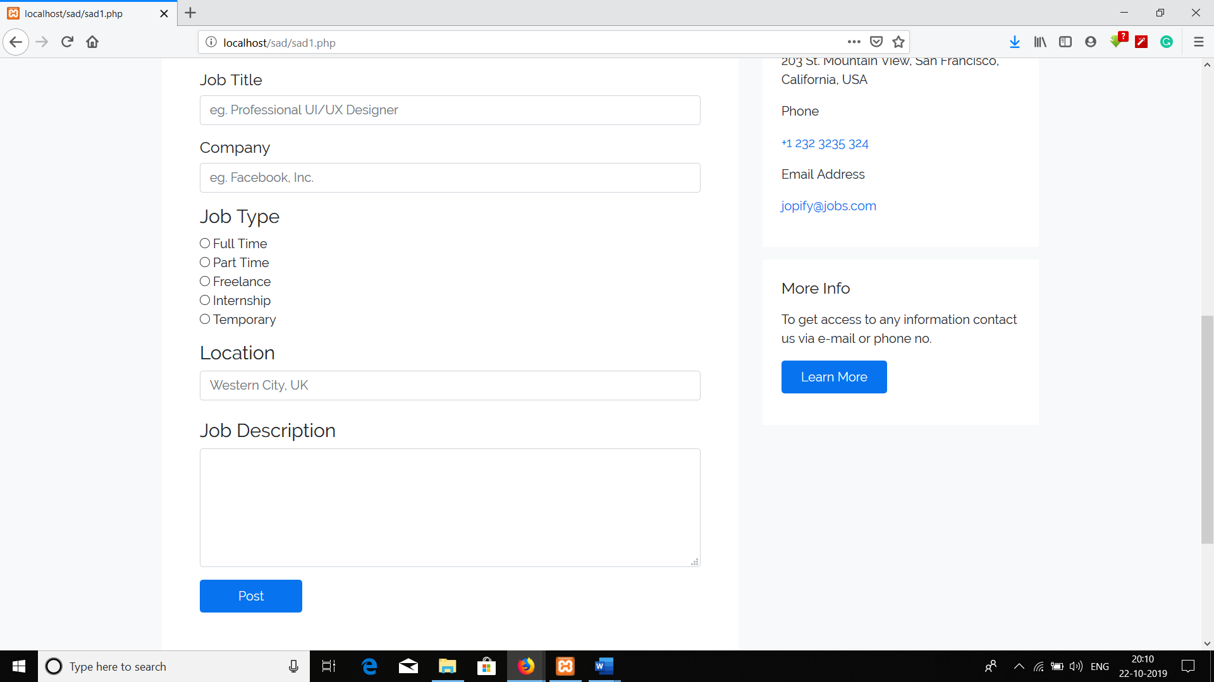

**Conclusion:**

It has been a great pleasure for us to work on this project. This project proved good for us as it provided practical knowledge of programming in PHP and learning Architecture Design. Web based application and XAMPP Server and SQL Server, but also about all handling procedure related with “JOB PORTAL”. It also provides knowledge about the latest technology used in developing web enabled application and client-server technology that will be great demand in future. This will provide better opportunities and guidance in future in developing projects.

**Future Scope:**

This System being web-based and an undertaking of Cyber Security Division, needs to be thoroughly tested to find out any security gaps.

A console for the data centre may be made available to allow the personnel to monitor on the sites which were cleared for hosting during a particular period.

Moreover, it is just a beginning; further the system may be utilized in various other types of auditing operation viz. Network auditing or similar process / workflow based applications.